**Name -Monika Gariya**

**Email-** [**monikagariya2023@gmail.com**](mailto:monikagariya2023@gmail.com)

**Data Engineering Batch 1**

**Date – 13-02-2024**

**Microsoft Azure**

**Topic – Cluster, Databricks Visualization**

**1)Cluster**

In Azure Databricks, cluster is a series of Azure VMs that are configured with Spark, and are used together to unlock the parallel processing capabilities of Spark. In short, it is the compute that will execute all of our Databricks code.

There are two main types of clusters in Databricks :

1)**Interactive**: An interactive cluster is a cluster which we manually create through the cluster UI, and is typically shared by multiple users across multiple notebooks.

**2)Job**: A job cluster is an cluster that is tied to a Databricks Job. It spins up and then back down automatically when the job is being run.

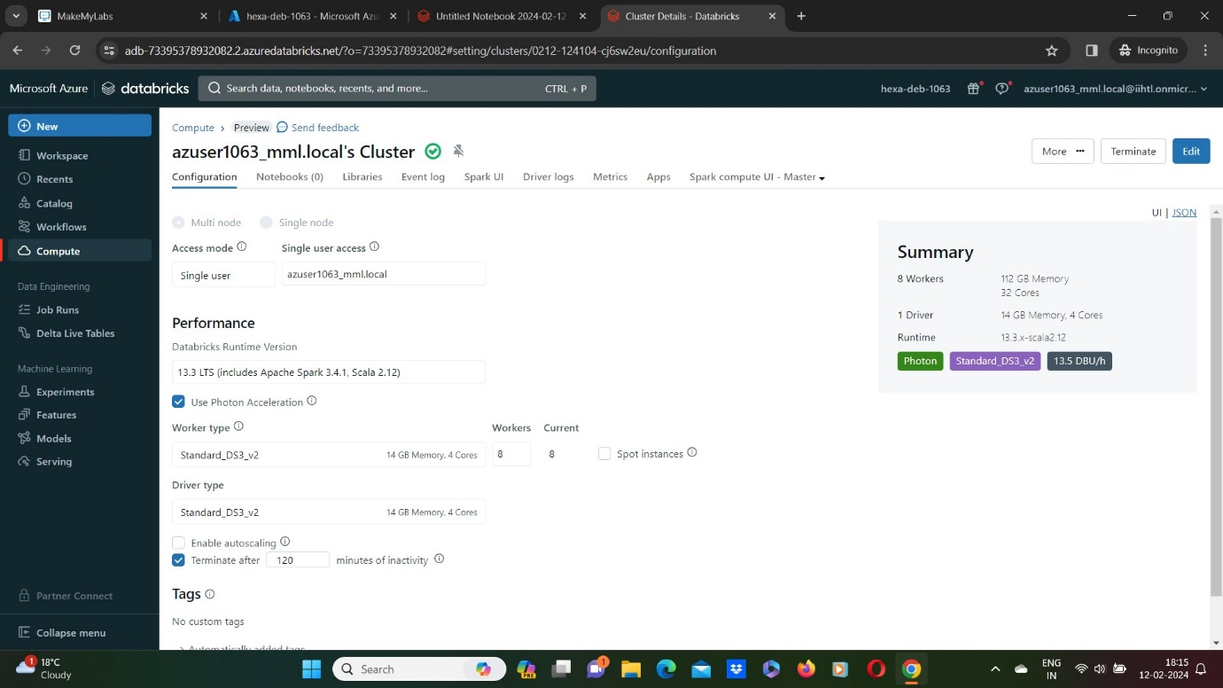

**2)Create a new Visualization**

In order to create visualizations, we need to have data.

Here I provided a data and used display() method.

* After creating a table
* Click on + symbol
* Click on visualization.
* Select the type of visualization, here I selected “Scatter”

